Package Name | Class Name | Use
Java.lang.System | System | PrintStream out, in
Java.io. PrintStream | PrintStream | println() , out, in
Java.io.Console | Console | writLine(),readLine()
Java.util.Scanner | Scanner | Scanner sc
Java.lang.<All wrapper classes>  =>implements Serializable and Comparable | Boolean  Character  Number  Byte  Short  Integer L Long  Float Double
Java.io.FileInputStream | FileInputStream
Java.io.FileOutputStream | FileOutputStream
Java.io | FileReader | used to read the data in the form of character from text file
Java.io | FileWriter | used to write the data in the form of character into text file
Java.sql.
java.lang.Error | Error
Java.lang.String | String
Java.lang.Object | Object
Java.lang.Comparable | Comparable | Has single abstract method  Used to compare objects  Compare on natural ordering
Java.util.Date
Java.util.Calender | Calender
Java.time.LocalDate|  LocalTime|LocalDateTime | LocalDate  LocalTime|LocalDateTime
Java.io.File | File
java.util.Stream | Stream
java.lang.Thread | Thread

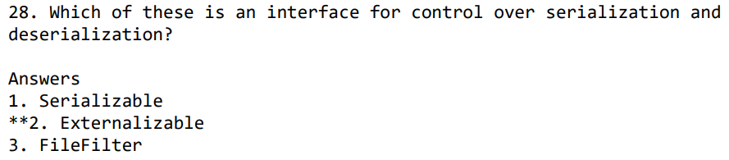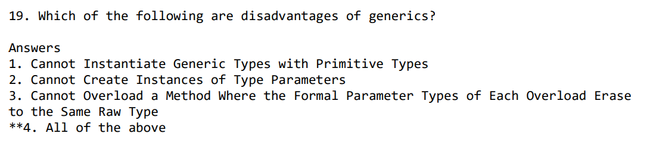
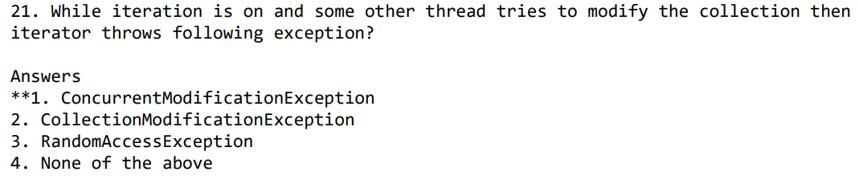
- toArray() => method can be used to obtain a array from an ArrayList object
- Compiler Error because base class exception is caught before derived class
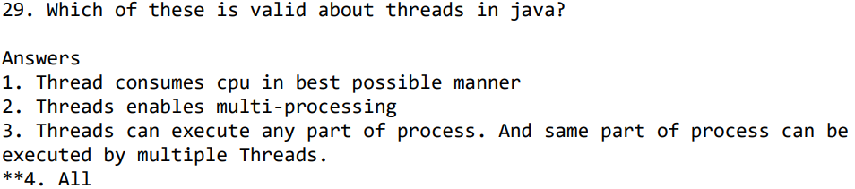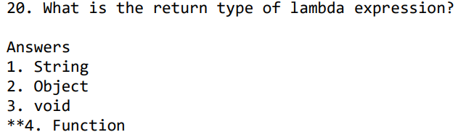
- Green threads in Java refer to a type of thread that is managed by the virtual machine (VM) rather than the underlying operating system.
- Exceptions in Java arises in code sequence at RUNTIME
- Only the garbage collection system can destroy an object =>programmer can’t destroy

- Map m1 = Collections.synchronizedMap(hashMap) =>to synchronize map

- int hashCode() => Object class method =>return type int

Methods throws SQLException
ResultSet executeQuery(String sql); => SQL statement, which returns a single object.
int executeUpdate(String sql) ; => SQL DDL statement.(insert,update,delete)
boolean execute(String sql) ; => SQL statement, which may return multiple results
int[] executeBatch(); =>batch of cmds , returns an array of update counts.

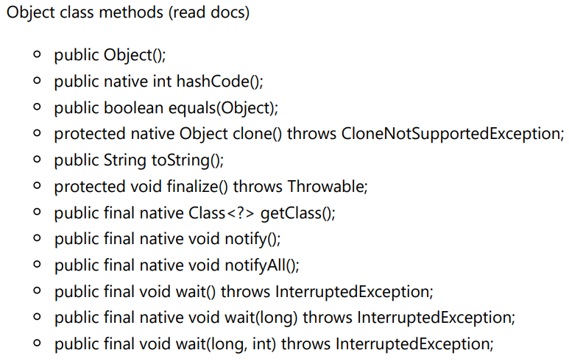
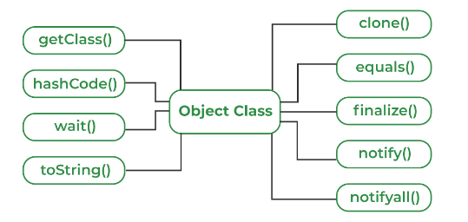 Marker Interfaces:
java.io.Serializable -- Allows JVM to convert object state into sequence of bytes.
java.lang.Cloneable -- Allows JVM to create copy of the class object.
java.rmi.Remote -- It marks an object as remote that can be accessed from another machine (host).
java.lang.Comparable -- is a Java interface that defines a method for comparing objects to determine their natural ordering.

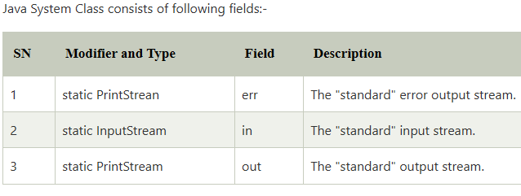
Static void gc() => Runs the garbage collector.

Java.lang.Throwable
Error  =>generated due to runtime environment  => not to handle |  | Exception  =>except Runtime exception class  All are checked exception
Virtual Machine Error | IOError | Checked Exception  =>Checked at compile time  =>forced to handle | Unchecked Exception  =>Not Checked By Compiler  =>No need to handle
OutOfMemoryError |  | CloneNotSupportedException | ArithmeticException
StackOverflowError |  | IOException | ClassCastException
 |  | InterruptedException | IndexOutOfBoundsException(Array and String)
 |  |  | NegativeArraySizeException
NoSuchElementExceptio
=>InputMismatchException
 |  |  | NullPointerException

final classes
- java.lang.String: "Immutable" character sequence
- java.lang.StringBuffer: Mutable character sequence (Thread-safe)
- java.lang.StringBuilder: Mutable character sequence (Not Thread-safe)
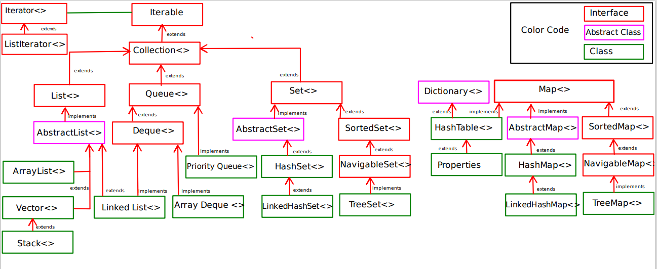

Iterable |  |  |  |  |  | Dictionary
Collection
List | Queue |  | Set |  | Map
ArrayList | Deque |  | HashSet |  | HashMap | HashTable
LinkedList | Linked List | Priority  Queue | LinkedHashSet |  | LinkedHash  Map | Properties
Vector  =>Stack | Array  Deque |  | TreeSet |  | TreeMap

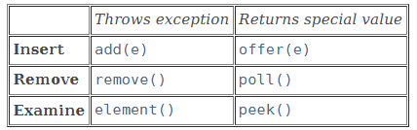
E add() - throw IllegalStateException if full.
E remove() - throw NoSuchElementException if empty
E element() - throw NoSuchElementException if empty

